User guide for BCOMS (Biologically constrained optimization based cell membrane segmentation)

Yusuke Azuma and Shuichi Onami

Laboratory for Developmental Dynamics, RIKEN Quantitative Biology Center, 2-2-3 Minatojima-minamimachi, Chuo-ku, Kobe, Hyogo 650-0047, Japan

1. Installation
   1. Go to <https://github.com/bcomsCelegans/BCOMS>
   2. Download the file [BCOMS_Installer_web.exe](https://github.com/bcomsCelegans/BCOMS/blob/master/BCOMS_Installer_web.exe)
   3. Run the downloaded file. Installation starts automatically.
2. Read image files
   1. Run the BCOMS.exe. The following window opens.
   2. Input the following image data information.

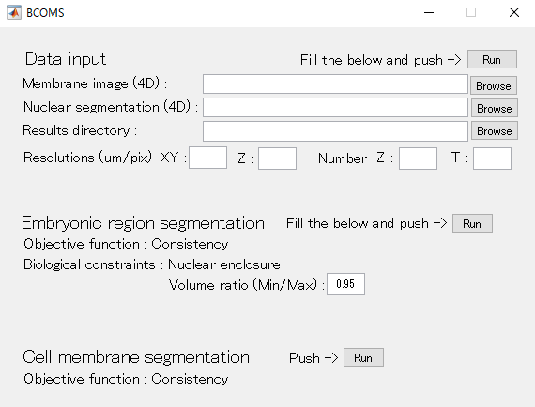

* + 1. Membrane image (4D): Path to the membrane image. The file must be multi frame single image file containing 4D (3D time-lapse) data.
    2. Nuclear image (4D): Path to nuclear seed image. The file must be multi frame single image file containing 4D (3D time-lapse) data. The size of the image must be identical to the membrane image.
    3. Results directory: Path to directory to save result files.
    4. Resolutions (um/pix): Image resolutions in XY and Z. The Z resolution is a space between adjacent focal planes.
    5. Number: The number of Z (focal planes) and time points of the membrane image and nuclear seed image.
  1. After filling all the blanks, push the Run button at upper right. If there is unfilled blank, the following error message is shown.
  2. If all the information is properly given, the following message window is shown.

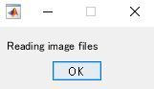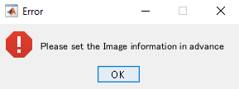

* 1. After both files are read, the following message window is shown.

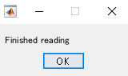

* 1. The membrane image and seed nuclear files are read and the following directories and files are created under the Results directory.
     1. *Results_directory*/MembraneImage/stack.mat: mat file of the membrane image.
     2. *Results_directory*/NuclearImage/stack.mat: mat file of the seed nuclear image.

1. Embryonic region segmentation
   1. For the embryonic region segmentation, an optimal segmentation is found by solving a biologically constrained optimization. The constraints are comprised from equality and inequality constraints. The equality constraint forces all the seed nuclei to be enclosed by its embryonic region. It does not need parameters and automatically applied. The inequality constraint forces the volume of embryonic region to be nearly stable across the time length of the image data. The stability is given as ratio of maximal and minimal volumes during the time length. You need to input the ratio as value at the blank where the default value of 0.95 is initially given.
   2. After filling the blank, push the Run button at middle. Computation of the embryonic region starts and the following message window is shown.

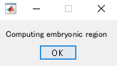

* 1. After the computation finishes, the following message window is shown.

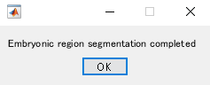

* 1. The embryonic region segmentation result file is created at the following location.
     1. *Results_directory*/ EmbReg /Stack/stack.mat

1. Cell membrane segmentation
   1. In the cell membrane segmentation, the nuclei-seeded watershed ensures that each nucleus is enclosed within its defining cellular region. Therefore, the equality constraint is implicitly applied. The Volumes of cells might be variable throughout cell cycle, so that the constraint about the volume stability is not applied.
   2. Push the Run button at bottom right. Computation of the cell membranes starts and the following message window is shown.

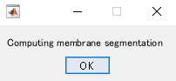

* 1. After the computation finishes, the following message window is shown.

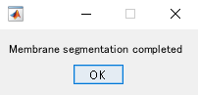

* 1. The cell membranes and cellular regions segmentation results are saved as 2D image files under the following directories.
     1. *Results_directory*/ MembraneSegmentation/Cell
     2. *Results_directory*/ MembraneSegmentation/Membrane